**3.7 Session 7 reflection**

Remember to clearly cite all sources. Please show your code where applicable and discuss any  
advantages or disadvantages of your choice of tools that you perceive during the process. The  
first three questions are worth one point each, the last three are worth two points each.

Another option, in case neither MongoDB nor Apache Cassandra has caught your attention, is  
Redis (https://redis.io/) that also supports JSON. As always, you are free to bring other  
similar tools to the table instead of limiting yourself to the alternatives provided in the example  
codes.

1. What do we gain when we use JSON instead of CSV to represent data in terms of flexibility and efficiency? Think, investigate, and speculate.

* Most used on a web-based applications.
* Simple, lightweight, and easy to read and manipulate.
* No need to be downloaded and open in a text editor to be readable
* Easy to use with APIs and debug

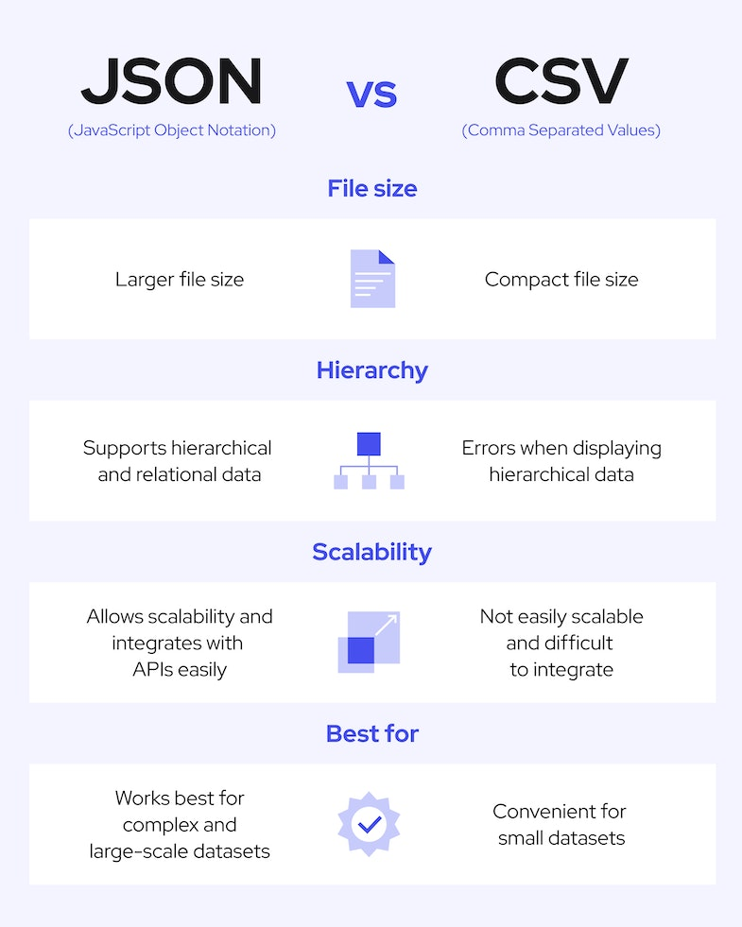

Ref: <https://www.geeksforgeeks.org/difference-between-json-and-csv/>

[JSON vs. CSV: Key Differences | Coresignal](https://coresignal.com/blog/json-vs-csv/" \o "JSON vs. CSV: Key Differences | Coresignal" \t "_blank)

1. Write a query to return specific data (instead of the whole collection) in an interactive  
   noSQL database shell (such as mongo shell), either using the example collections or your own data to populate two or more collections with at least two elements each.

Source: <https://code.visualstudio.com/docs/azure/mongodb>

https://www.section.io/engineering-education/rendering-html-pages-as-a-http-server-response-using-node-js/

1. Implement that same query through NodeJS or another access technology that is not the  
   interactive shell of the database technology you chose.
2. Return the query results over HTTP in HTML (with CSS if you wish) with the web server  
   technology of your choice.
3. Create a HTML form to control the query parameters, again with the tools of your  
   choice.
4. With the tools of your choice, connect the noSQL database as back end into the query-form front end.